NAME:J.K.RISHIK
REG.NO:192511052

ASSIGNMENT 3

TASK 1
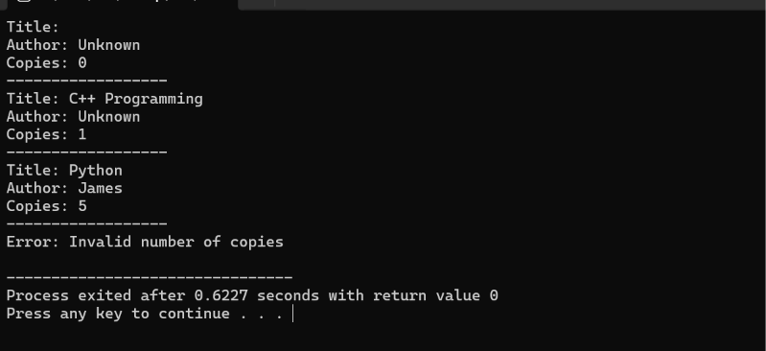
TASK 2
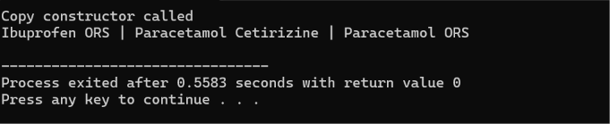
TASK 3
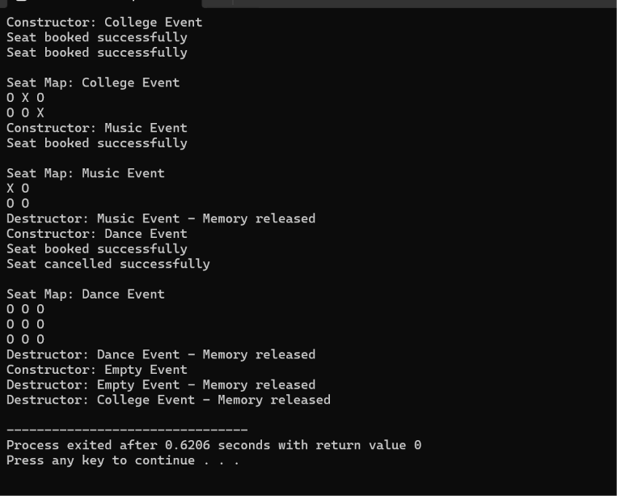

TASK 4

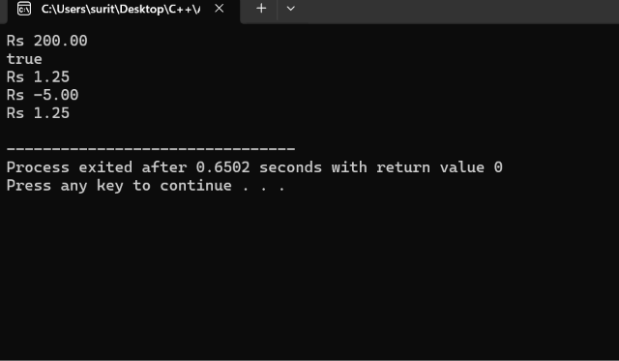

TASK 5
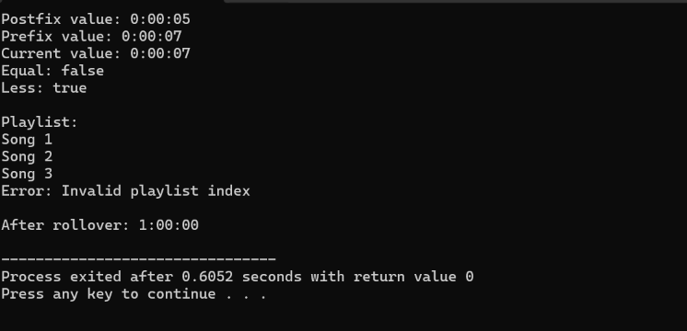

TASK 6
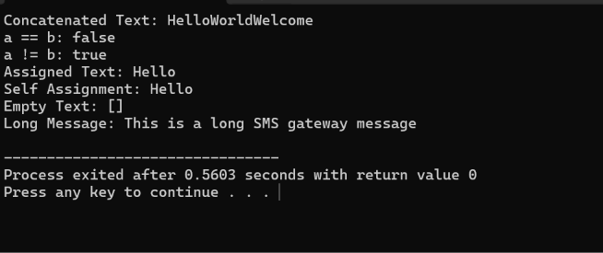

TASK 7


